Lab Assignment 1

Write a python program to create a neuron and predict its output using the threshold activation function.
import numpy as np

BIAS = 1
THRESHOLD = 5

class Neuron:
def __init__(self,weights,bias,threshold=0):
'''Initializing neuron with weights, bias, threshold(default is 0)'''
# Changed the Python List to Array Easier to do calculation(dot prod) in Array
self.weights = np.array(weights)
self.bias = bias
self.threshold = threshold

def predict(self,inputs):
'''Predicts if neuron will fire or not, depending on calculated weigthed sum and threshold function'''
# Weighted sum = v in the slides
# NumPy Library dot products(scalar product) of 1D array
weighted_sum = np.dot(self.weights,inputs) + self.bias
if weighted_sum > self.threshold:
return 1
return 0

# Prompting Input from the user
no_of_inputs = int(input("Enter the number of inputs of neuron: "))

# List of input(x)
inputs=[]
# List of Weight(w)
weights =[]

# Values of input(x) and weigths(w)
for i in range(0,no_of_inputs):
x=float(input(f"Enter the value of Input x{i+1}: "))
w=float(input(f"Enter the value of Weight w{i+1}: "))
inputs.append(x)
weights.append(w)

# Creating a object
neuron = Neuron(weights=weights,bias=BIAS,threshold=THRESHOLD)

# Final output of the ANN (y)
output = neuron.predict(inputs=inputs)

if output ==1:
print(f"Neuron Fired. y={output}")
else:
print(f"Neuron not Fired. y={output}")

Output
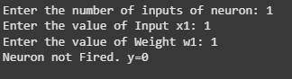

Write a python program to train AND Gate Using Perceptron Learning Algorithm.
import numpy as np

EPOCHS = 10
LEARNING_RATE = 1

# Step function (Activation function)
def step_function(value):

# Threshold at 0
return 1 if value >= 0 else 0

class Perceptron:

def __init__(self, input_size, learning_rate=1):
# Initialize weights as 0 (Can be Initialized Randomly as well)
self.weights = np.random.rand(input_size) # Makes NumPy Array of <input_size>
# Initialize bias as 0 (Can be Initialized Randomly as well)
self.bias = np.random.rand()
self.learning_rate = learning_rate

def predict(self, inputs):
"""Takes Inputs array to predict the output"""
weighted_sum = np.dot(inputs, self.weights) + self.bias

# Returning after calling the Activation Function
return step_function(weighted_sum)

def train(self, training_inputs, target_outputs, epochs=10):
"""Takes the AND Gate (x1,x2) and y to train """
for epoch in range(epochs): # Repeat for multiple epochs

# print(f"\nEpoch {epoch+1}")
# print(" ----------------------")

for inputs, target_output in zip(training_inputs, target_outputs):
prediction = self.predict(inputs)
error = target_output - prediction # Calculate (Target Output (t) - Acutual Output(y))

# print(f"Input: {inputs}, Prediction: {prediction}, Expected: {target_output}, Error: {error}")

# Update weights and bias using perceptron learning rule
self.weights += self.learning_rate * error * np.array(inputs)
self.bias += self.learning_rate * error

# print(f"Updated Weights: {self.weights}, Updated Bias: {self.bias}")

# From AND Gate Table (x1,x2)
training_inputs = np.array([
[0, 0],
[0, 1],
[1, 0],
[1, 1]
])
# From AND Gate Table (y) Outputs
target_outputs = np.array([0, 0, 0, 1])

# Initialize and train perceptron
perceptron = Perceptron(input_size=2, learning_rate=LEARNING_RATE)
perceptron.train(training_inputs=training_inputs, target_outputs=target_outputs, epochs=EPOCHS)

# Testing the trained perceptron
print("\nTesting AND Gate Perceptron:")
for inputs in training_inputs:
print(f"Input: {inputs}, Predicted Output: {perceptron.predict(inputs)}")

Output
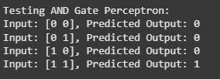

Write a python program to implement Min-Max Scalar.

import numpy as np

class MinMaxScaler:
def __init__(self):
self.min = None
self.max = None
def fit(self,data):
'''Getting the required parameters(min,max)'''
# axis=0:find the minimum value in each column.
self.min = np.min(data, axis=0)
self.max = np.max(data, axis=0)

# Transform data in range(0,1)
def transform(self,data):
'''Normalizing the data in range 0 to 1'''
# Output Data array
output = np.round((data - self.min) / (self.max - self.min),3)
return output

def fit_transform(self, data):
'''Combining the fit and transform'''
self.fit(data)
return self.transform(data)

# Sample dataset
data = np.array([[5.9, 75],[5.8, 86],[5.2, 50],[5.4, 55],[6.1, 85],[5.5, 62]])

# Create a MinMaxScaler object
scaler = MinMaxScaler()

# Fit and transform the data
scaled_data = scaler.fit_transform(data)
print("Original Data:\n", data)
print("\nScaled Data:\n", scaled_data)

Output
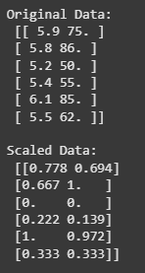

Write a python program to implement Standard Scalar.
import numpy as np

class StandardScaler:
def __init__(self):
self.mean = None
self.std = None

def fit(self,data):
'''Gets the required parameter(mean and SD)'''
self.mean = np.mean(data, axis=0)
self.std = np.std(data, axis=0)

def transform(self,data):
'''Transforms the data (Normalizes)'''
return np.round((data - self.mean) / self.std, 3)

# Applying standard scaling
def fit_transform(self, data):
'''Combining fit and transfrom'''
# calling fit
self.fit(data)

#Returning the normalized data
return self.transform(data)

# Sample dataset
data = np.array([[5.9, 75], [5.8, 86], [5.2, 50], [5.4, 55], [6.1, 85], [5.5, 62]])

# Create a StandardScaler object
scaler = StandardScaler()

# Fit and transform the data
scaled_data = scaler.fit_transform(data)

print("Original Data:\n", data)
print("\nStandardized Data:\n", scaled_data)

Output
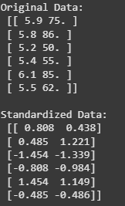

Write a python program to train perceptron using given training set and predict class for the input (6,82) and (5.3,52)
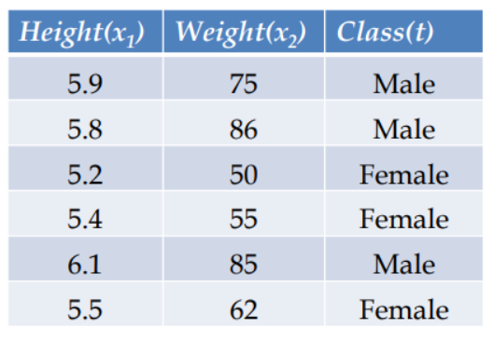

import numpy as np

class Perceptron:
def __init__(self, input_size, learning_rate=1, epochs=5):
self.weights = np.zeros(input_size) # Initialize weights to zeros
self.bias = 0 # Initialize bias to 0
self.alpha = learning_rate # Learning rate
self.epochs = epochs # Number of epochs
self.X_min = None
self.X_max = None

def activation_func(self, x):
"""Activation function: Returns 1 for positive, -1 for negative"""
return 1 if x >= 0 else -1

def maxmin_normalize(self, X):
"""Normalizing the data between 0 and 1 using Min-Max Scaling with zero-division handling"""

if self.X_min is None or self.X_max is None:
self.X_min = np.min(X, axis=0)
self.X_max = np.max(X, axis=0)

# PROBLEM: Division by zero if max and min same
denominator = self.X_max - self.X_min

#SOLUTION: Replacing the 0 with 1 to avoid division by zero
denominator[denominator == 0] = 1

return np.round((X - self.X_min) / denominator, 3)

def train(self, X, y):
"""Trains the perceptron using given inputs and target values"""
# Normalize data before training
X = self.maxmin_normalize(X)

for epoch in range(self.epochs):
print(f"Epoch {epoch+1}:")
for i in range(len(X)):
# Weighted sum
v = np.dot(X[i], self.weights) + self.bias

# Apply activation function
y_pred = self.activation_func(v)

# Update weights and bias only if there's a misclassification
if y_pred != y[i]:
weight_update = self.alpha * (y[i] - y_pred) * X[i]
bias_update = self.alpha * (y[i] - y_pred)
self.weights += weight_update
self.bias += bias_update
print(f" Sample {i+1}: Weights = {self.weights}, Bias = {self.bias}")

def predict(self, X):
"""Predicts the class for given input"""
# PROBLEM: Due to not saving the min and max value of training data scaling problem occured and correct prediction was not made
# SOLUTION: Normalize test data using the same scaling as training data
X = self.maxmin_normalize(X)
v = np.dot(X, self.weights) + self.bias
return "Male" if self.activation_func(v) == 1 else "Female"

# Question Dataset
training_data = np.array([
[5.9, 75], [5.8, 86], [5.2, 50],
[5.4, 55], [6.1, 85], [5.5, 62]
])
target_outputs = np.array([1, 1, -1, -1, 1, -1]) # 1 = Male, -1 = Female

# Create and train perceptron
perceptron = Perceptron(input_size=2, learning_rate=1, epochs=5)
perceptron.train(training_data, target_outputs)

# Testing on new inputs
test_data = np.array([[6, 82], [5.3, 52]])

for i, test in enumerate(test_data):
# Passing to the Perceptron Obj to predict their Gender
prediction = perceptron.predict(np.array([test]))
print(f"Test case {i+1}: {test} → Predicted class: {prediction}")

Output
